Lab - AWS RDS

Step by step guide to create a AWS relational database

Step 1:login to aws account and navigate to RDS console.

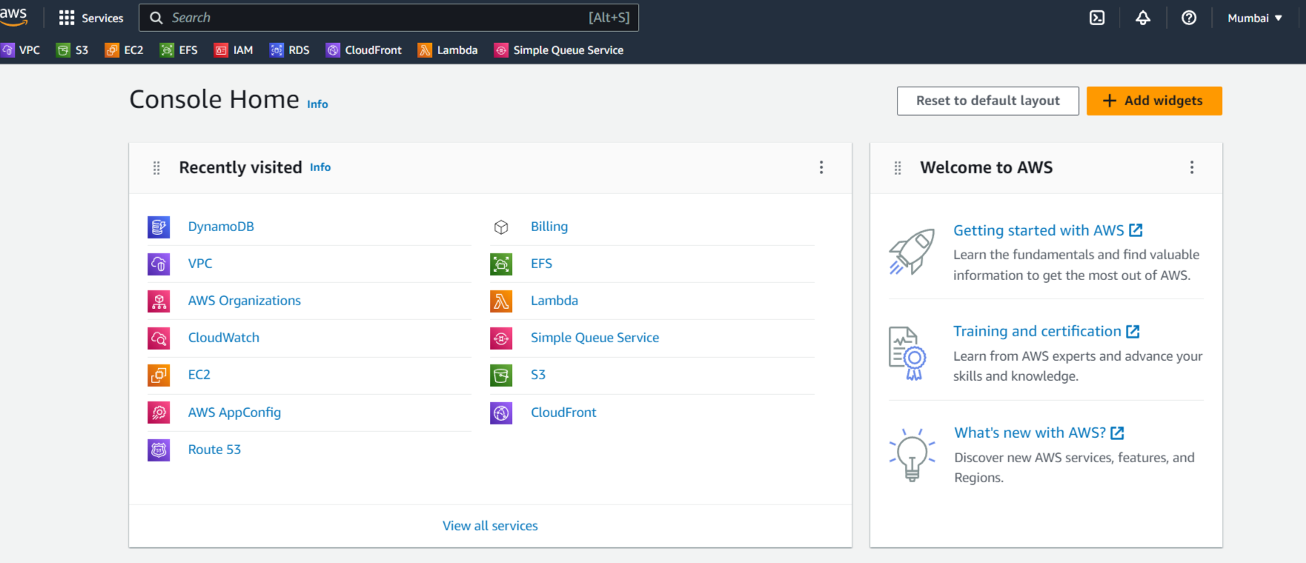

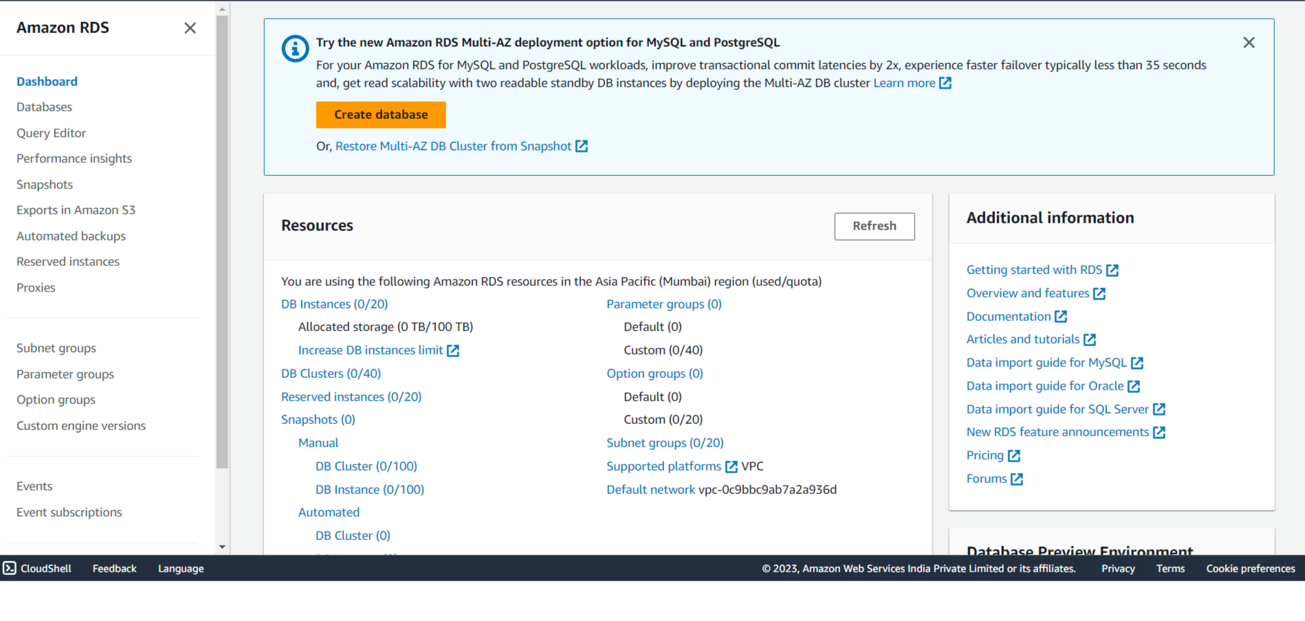

Step 2: click on “Create database” .

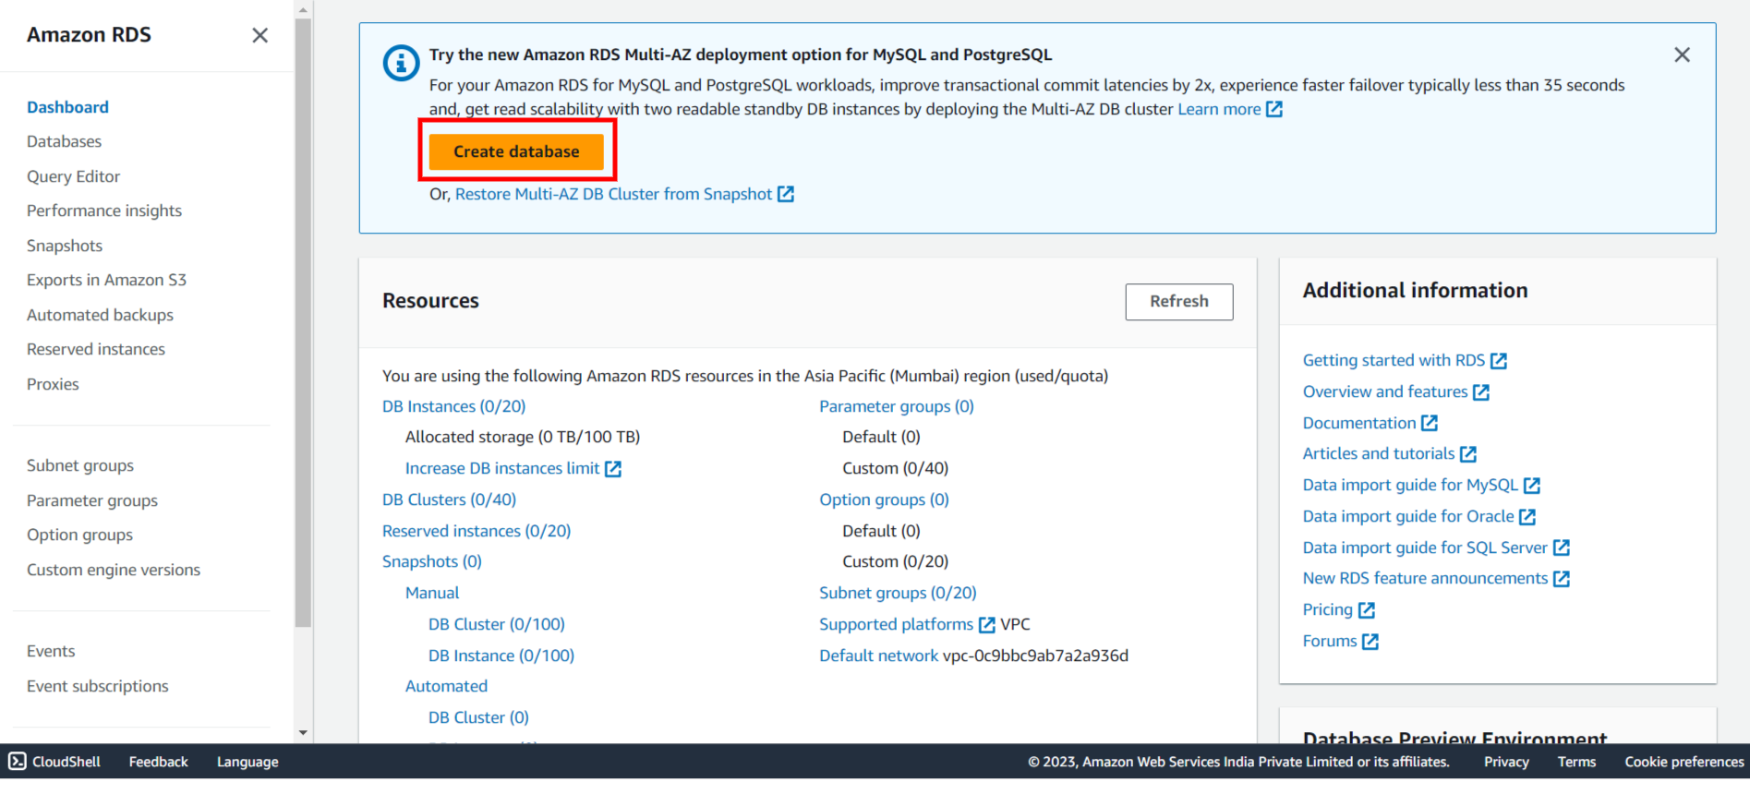

Step 3: Choose the database creation type and particular engine for your RDS.

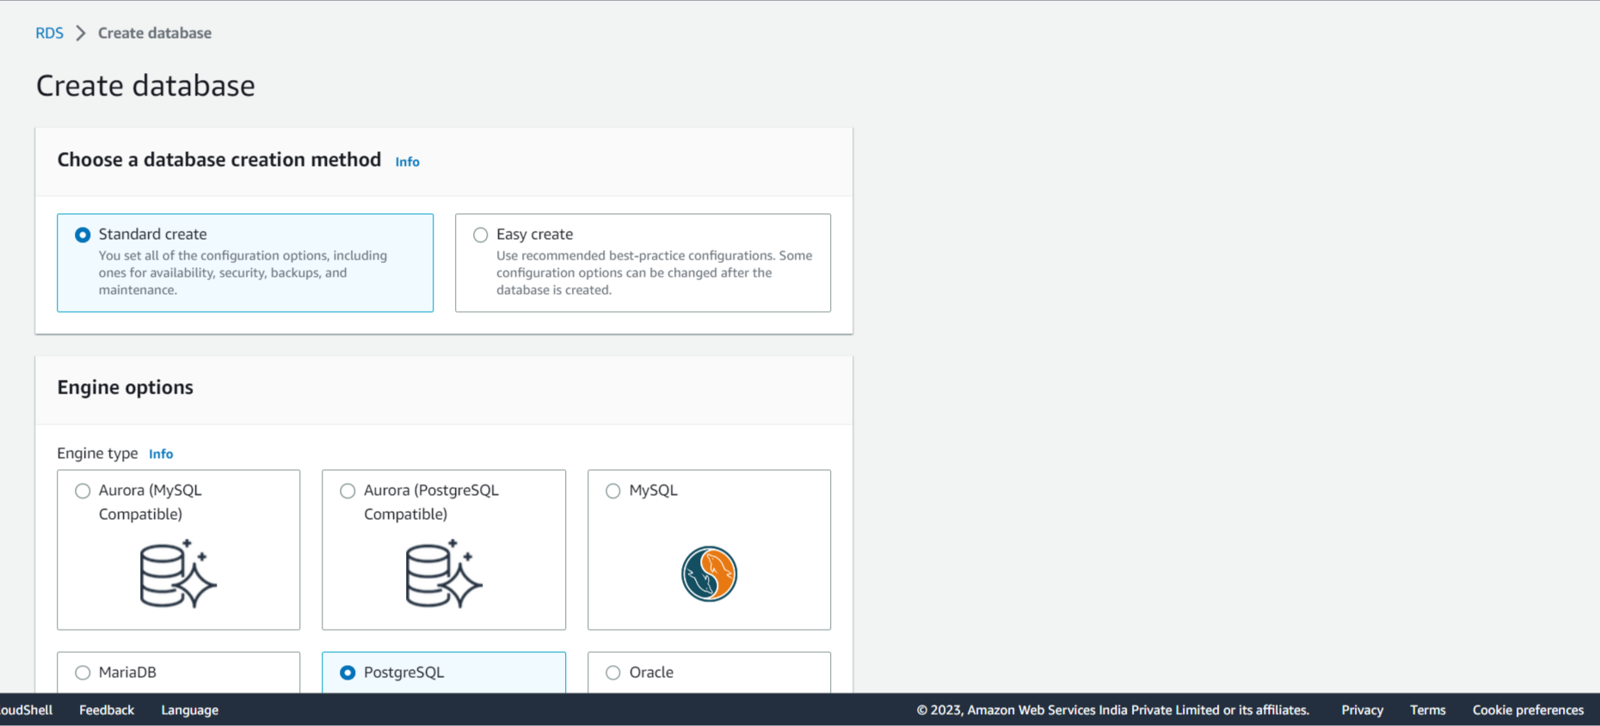

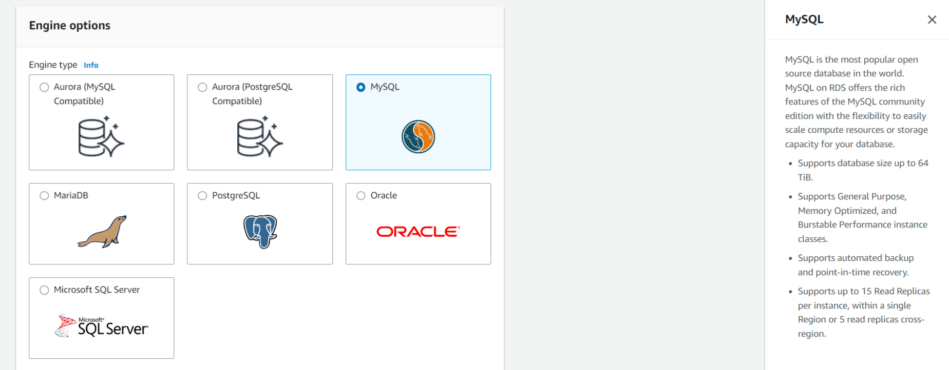

Step 4:Select the template and configure the availability and durability of your RDS.

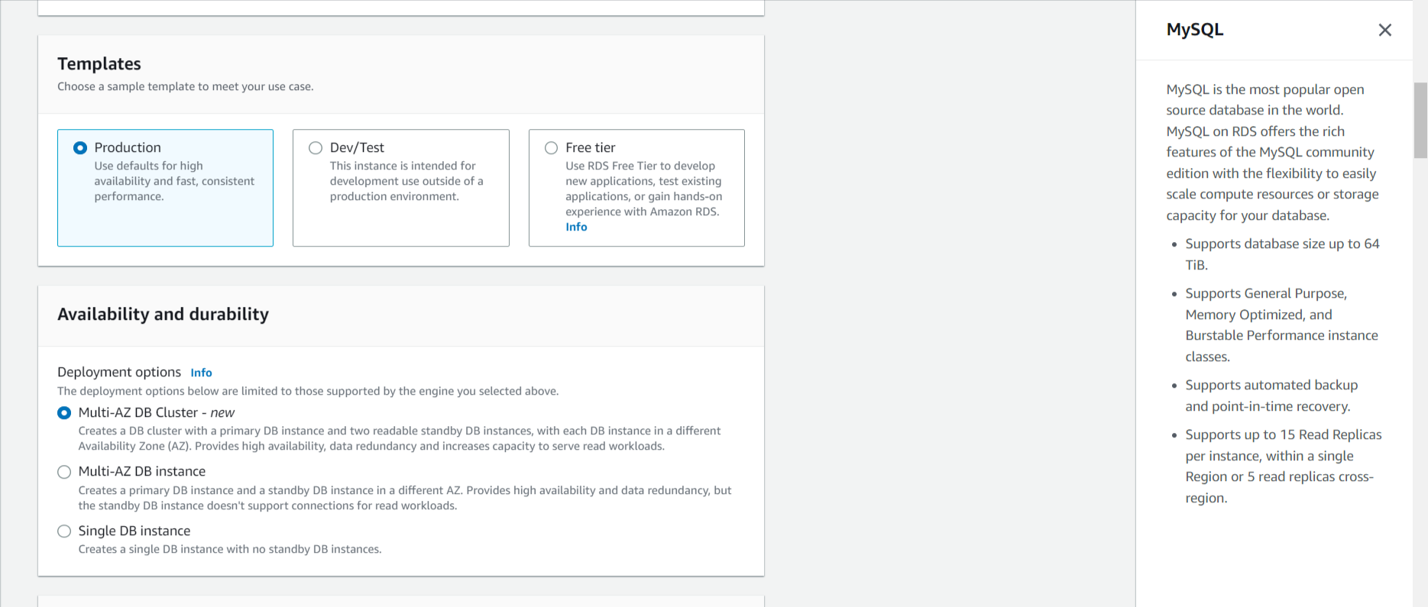

Step 5: Configure the settings of database identifier and security credentials like password.You can create your own password or generate an auto password.

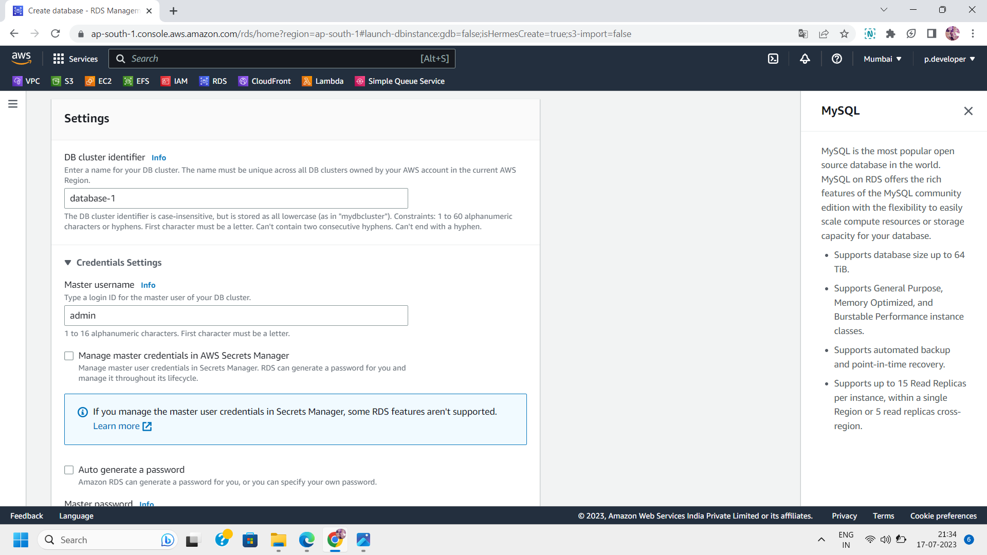

Step 6: Manage the Instance configuration:

Select the instance class such as standard classes or memory optimized classes.

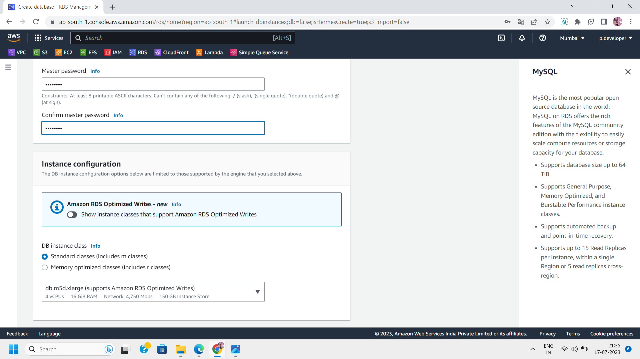

Step 7: Configure the Storage settings such as storage type,allocated storage,storage autoscaling and provisioned IOPS .

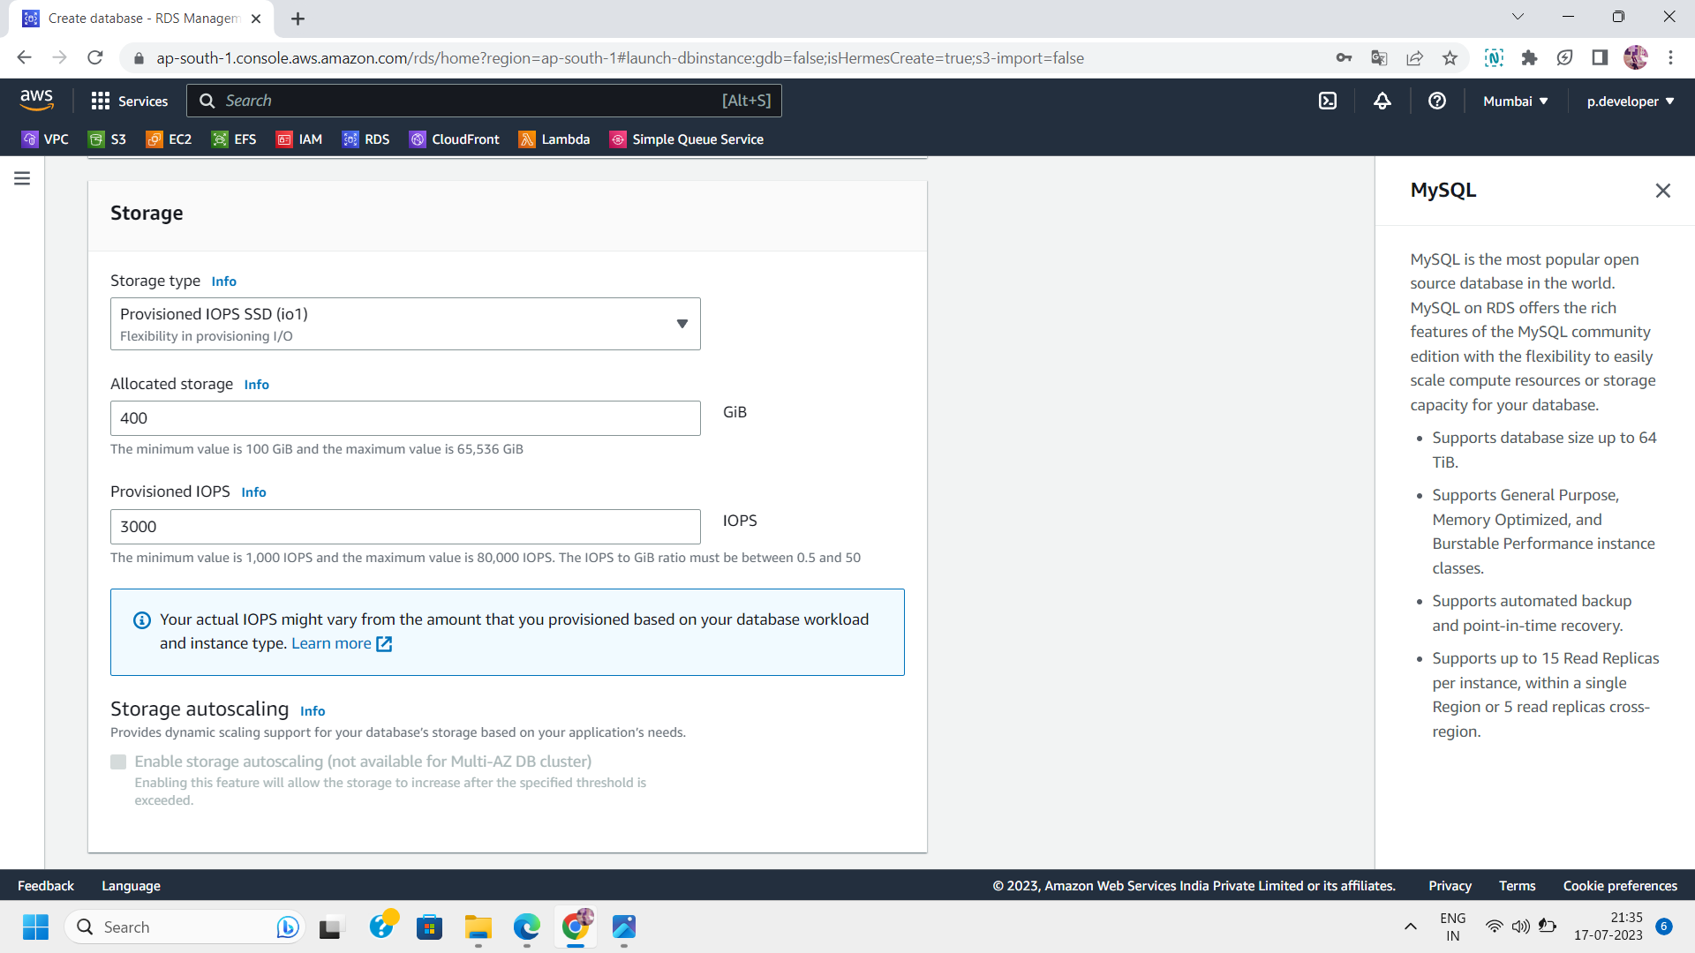

Step 8: Manage the connectivity :

Select the instance you want to connect and also VPC and database subnets .Specify the public level access to your database.

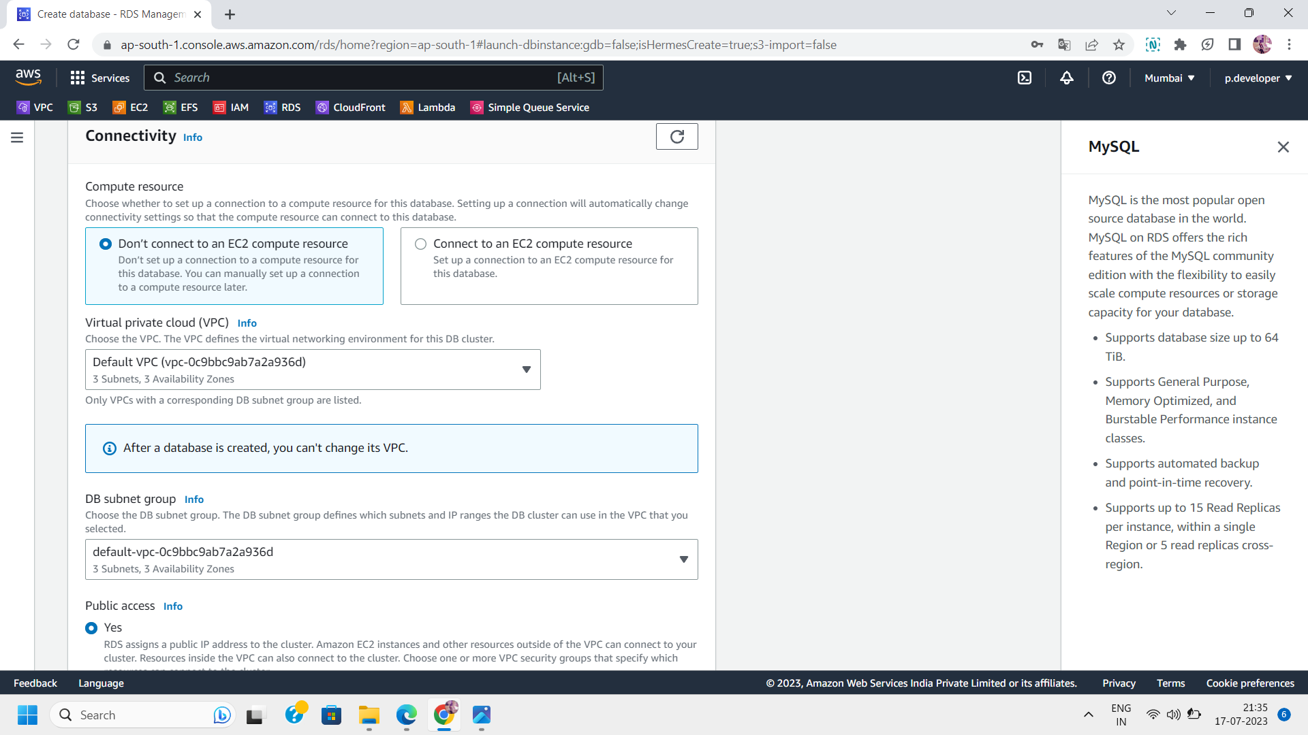

Step 9:Configure the Monitoring settings:

Define the retention period,performance insights and AWS KMS key.

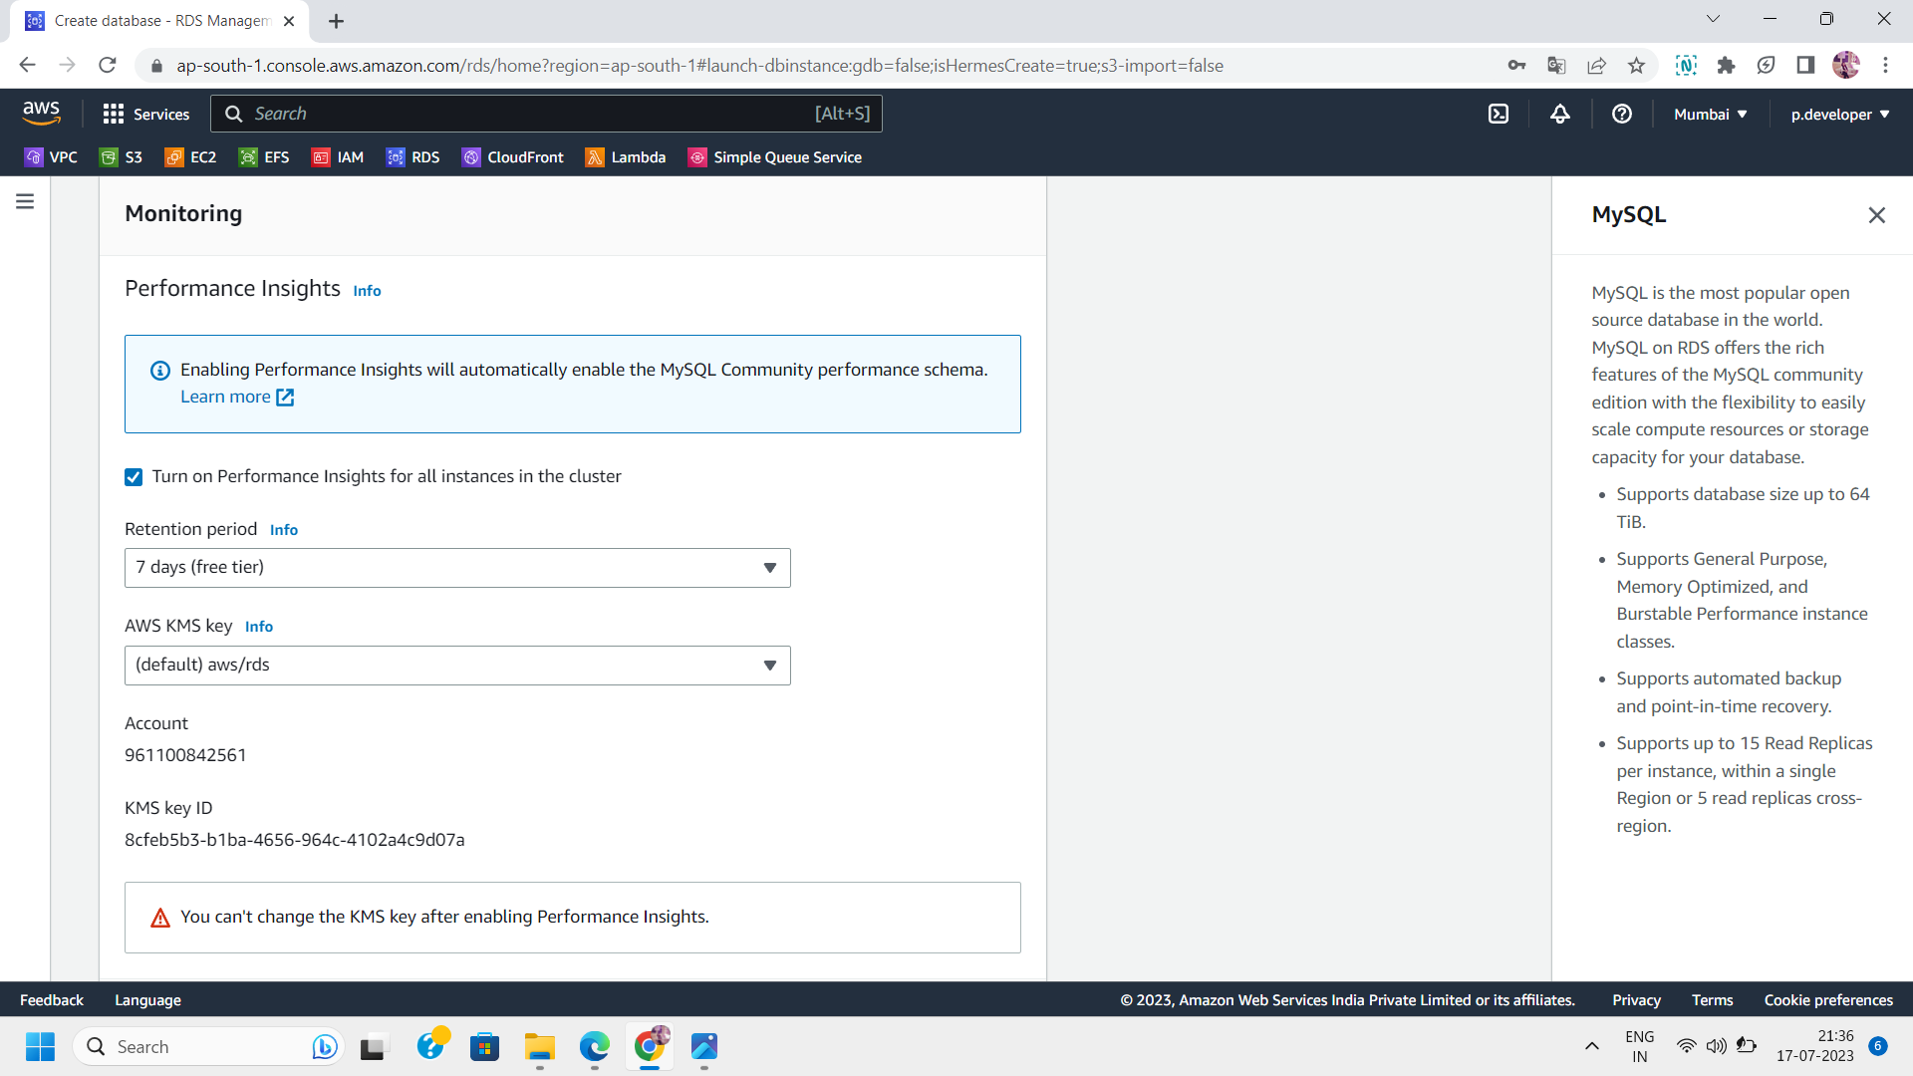

Step 10:Manage Additional configurations(Optional):

Its is optional but you can check additional settings of your database.

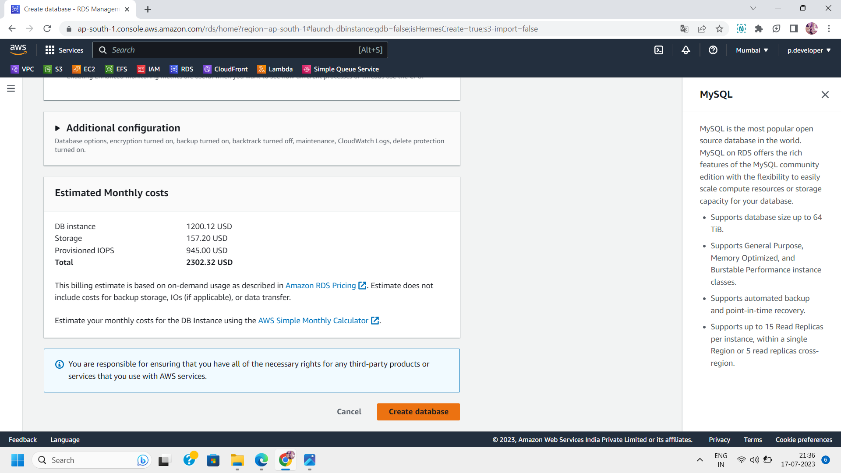

Step 11: On clicking “ Create database” ,it takes some time and then your database will be ready to use .You can connect your database to your instance and implement various queries.

